**Figure S1:** RAS components and related enzymes that showed only uncorrected significant differences in gene expression between normal and tumor tissues. From top to bottom the panels describe angiotensin-converting enzyme gene (*ACE*) expression, chymase gene (*CMA1*) expression, AT2 receptor gene (*AGTR2*) expression, and prolyl carboxypeptidase gene (*PRCP*) expression, left panels show pairing of samples with connecting lines. Right panels show mean, SEM and individual data points. All of these comparisons were significant at the p<0.05 level before correction for multiple comparisons but were not significant after correction for multiple comparisons.

**Figure S2:** RAS components that did not show any significant differences in *gene* expression between normal and tumor tissues. Top panels describe AT1 receptor gene (*AGTR1*) expression, middle panels describe AT4 receptor gene (*LNPEP*) expression and lower panels describe angiotensin-converting enzyme-2 gene (*ACE2*) expression. Left panels show pairing of samples with connecting lines. Right panels show mean, SEM and individual data points.

**Figure S3:** Relative expression of angiotensinogen gene (*AGT)*, with different stages of CRC at time of biopsy. One-way ANOVA revealed a significant (F6,105 = 3.117, p = 0.0075) effect of stage on gene expression. ** Post-hoc Bonferroni test indicated that *AGT* gene expression during stage 2B was significantly less (p<0.01) than during stage 1 or stage 4.

**Figure S1**

**Figure S2**

**Figure S3**

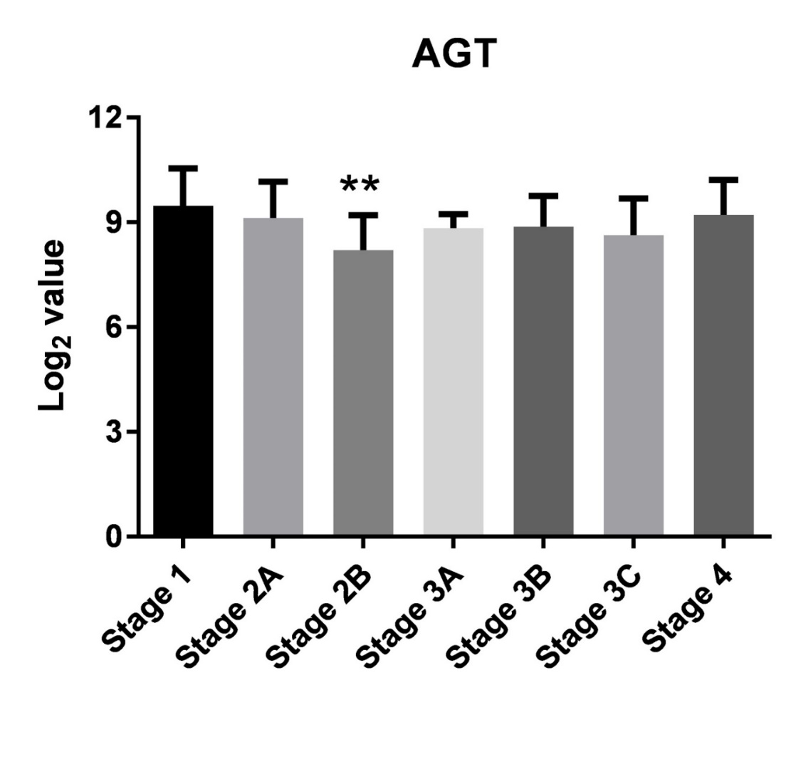

***AGT***